CS102 (161) with Prof. Dr. Basit Qureshi
Quiz 1. Weight 5%. Time allowed: 20 minutes
Name
ID

Code submission Document
Code submission: Copy-paste code for each class
<copy paste code here>

.
Code submission: Copy-paste code for each class
<copy paste code here>

.
Code submission: Copy-paste code for each class
<copy paste code here>

.

Proof of execution: Take a screen-shot of your netbeans Output tab. Use
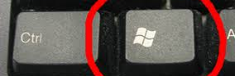 WINDOWS + SHIFT + S
Screenshot PICTURE here

.
Submission: Convert your document to a PDF file, do the following:
a. Go to File → Save As → Browse → Documents
b. Click on ‘save as type:’ and choose PDF(*.pdf)
c. Click on save to save this file
d. upload PDF file ONLY to LMS



